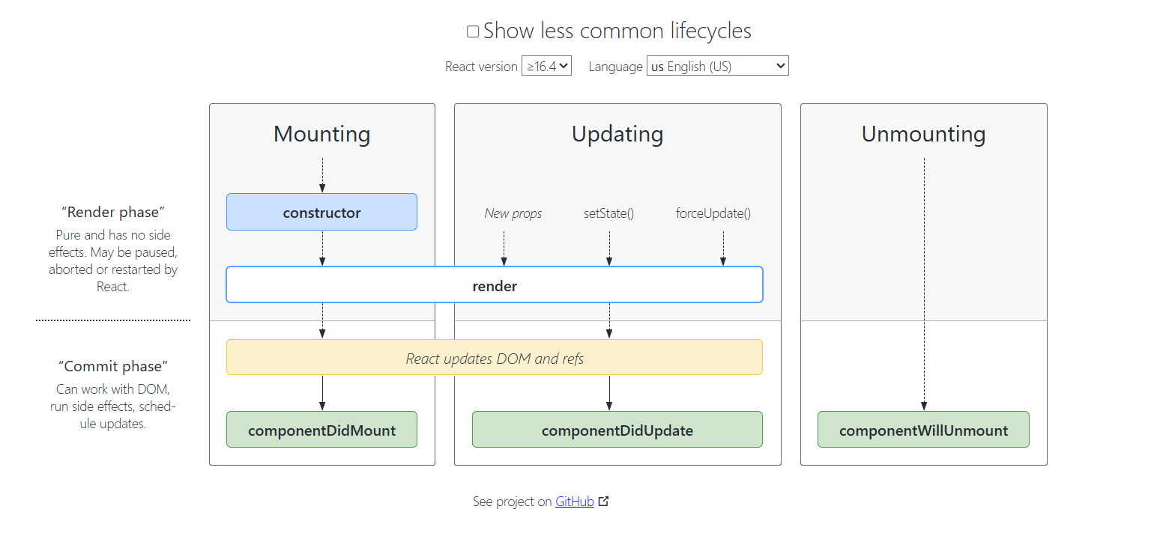

componentDidMount()

This method runs after the component output has been rendered to the DOM.

componentDidUpdate()

This method is invoked immediately after updating occurs.

componentWillUnmount()

This method is invoked immediately before a component is unmounted and destroyed. Perform any necessary cleanup in this method, such as invalidating timers, canceling network requests, or cleaning up any subscriptions that were created in componentDidMount().

import React from 'react'

import './Styles.css'

class Login extends React.Component{

    constructor(props){

        super(props);

        this.state = {lg: "Login with your credentials"};

    }

        authentication = () => {

        if (document.getElementById('Uname').value === 'SS' && document.getElementById('pwd').value === '123') {

            this.setState({lg:'Login Successful'});

        }

        else {

            this.setState({lg:'Login Failed'});

        }

    }

    render()

    {

    return (

        <div className='App-header'>

            <div>

            User Name: <input type='text' id='Uname' />

            <br/>Password: <input type='password' id='pwd' />

            <br/><button onClick={this.authentication}>Login</button>

            </div>

            <div className='App-header'>

            {this.state.lg}

            </div>

        </div>

          );

}

componentWillMount() {

    console.log('Component Will MOUNT!')

 }

 componentDidMount() {

    console.log('Component Did MOUNT!')

 }

 componentWillUpdate(nextProps, nextState) {

    console.log('Component Will UPDATE!');

 }

 componentDidUpdate(prevProps, prevState) {

    if(

        this.state.lg === prevState.lg

    )

    {

        console.log('Component Did not UPDATE!')

    }

    else

    {

        console.log('Component Did UPDATE!')

    }

 }

}

export default Login

**index.js**

import React from 'react';

import ReactDOM from 'react-dom/client';

import './index.css';

import Login from './Components/Login';

const root = ReactDOM.createRoot(document.getElementById('root'));

root.render(

       <Login/>,

 );

